***Bonding:***

**Allows atoms to get an octet Octet = 8 valence electrons**

**-Valence electrons are the electrons in the outermost S & P sublevels (last # in electron configuration on Periodic Table) -Maximum # of valence electrons = 8 (only 2 in smaller elements; ex: H, He)**

**-Endothermic = absorbing energy, which occurs when a bond is *BROKEN*  -Exothermic = releasing energy, which occurs when a bond is *FORMED***

**Hint: “absorb to break, release to make”**

**-Covalent Bonding = sharing of electrons -Non-polar covalent bond = sharing electrons equally -Polar covalent bond = sharing electrons unequally**

**-Ionic Bonding = transfer of electrons from a metal to a nonmetal, resulting in the formation of a positive ion (metal) and a negative ion (nonmetal) *metals lose electrons to form positive ions* *nonmetals gain electrons to form negative ions\***

***Ionic Bonding Lewis Dot Diagrams:***

**Steps: 1) write formula 2) draw the diagram for the metal(s) and nonmetal(s) 3) transfer the electrons from the metal to the nonmetal 4) write answer using brackets and charges *HINT* the metal should have no dots & a (+) charge, the nonmetal should have 8 dots and a (-) charge**

**[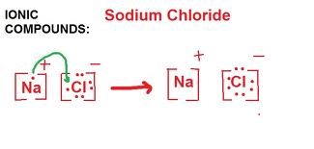](http://www.google.com/imgres?q=DOT+DIAGRAM+FOR+HYDROGEN+MOLECULE&hl=en&safe=active&biw=1280&bih=882&gbv=2&tbm=isch&tbnid=yNha_XPqmjV6-M:&imgrefurl=http://chem4three.blogspot.com/2010_11_01_archive.html&docid=baMBGRoGyN6_YM&imgurl=http://4.bp.blogspot.com/_z9emnNOdBIE/TM-R4Y-oN3I/AAAAAAAAAzQ/mXaxiCprNfE/s1600/sodium.jpg&w=740&h=354&ei=mxELT4rMDonw0gGCssWeAg&zoom=1)[http://t1.gstatic.com/images?q=tbn:ANd9GcT06XiX20FXdbOXwDG-neYFMlAIu1IEck1DGax0OAAEafHo3Rkr](http://www.google.com/imgres?q=%22lewis+dot+diagram+for+O2%22&hl=en&safe=active&gbv=2&biw=1280&bih=882&tbm=isch&tbnid=75uVUhBLinHh8M:&imgrefurl=http://www.ausetute.com.au/lewisstr.html&docid=gifWGyhso17eDM&imgurl=http://www.ausetute.com.au/images/edotliio.gif&w=50&h=50&ei=ywwLT66pMqLW0QHx_uT0DQ&zoom=1)[http://t1.gstatic.com/images?q=tbn:ANd9GcSAusF-0ffrGQMNH2keFHE7k8Jn6YW5qL4buovx7O41zghRpRvRDw](http://www.google.com/imgres?q=%22lewis+dot+diagram+for+O2%22&hl=en&safe=active&gbv=2&biw=1280&bih=882&tbm=isch&tbnid=B5GJTQ3G1TRXLM:&imgrefurl=http://www.ausetute.com.au/lewisstr.html&docid=gifWGyhso17eDM&imgurl=http://www.ausetute.com.au/images/edotoion.gif&w=50&h=50&ei=ywwLT66pMqLW0QHx_uT0DQ&zoom=1)**

***Noble Gas Electron Configurations:***

**After bonding, elements will have the same electron configuration as a noble gas**

**Examples:**

**1) NaCl Na 2-8-1becomes 2-8, the electron configuration of Neon [Ne] Cl 2-8-7 becomes 2-8-8, the electron configuration of Argon [Ar]**

**2) Li2O Li 2-1 becomes 2, the electron configuration of Helium [He] O 2-6 becomes 2-8, the electron configuration of Neon [Ne]**

**3) Al2S3 Al 2-8-3 becomes 2-8, the electron configuration of Neon [Ne] S 2-8-6 becomes 2-8-8, the electron configuration of Argon [Ar]**

***Ionic Character:***

**Ionic Character is determined by the difference in electronegativity between two atoms in a compound. The greater the difference, the greater the ionic character**

**Electronegativity (found on Table S) = an atom’s attraction for electrons; scaled from 0.0 to 4.0**

**Fluorine = 4.0**

**1.7 Rule -if the ionic character is greater than 1.7, the compound is ionic -if the ionic character is less than 1.7, the compound is covalent**

**Examples:**

**1) NaCl 2) CO2 3) O2 .9 3.2 2.6 3.4 3.4 3.4 3.2-.9= 2.3 3.4-2.6=.8 3.4-3.4=0**

***Covalent Bonding:***

**Sharing of electrons**

**1 bond = 2 electrons being shared molecule = covalent bonding**

**Polar Covalent Bonds = unequal sharing of electrons. Non-polar Covalent Bonds = equal sharing of electrons.**

**NON-POLAR MOLECULES POLAR MOLECULES -Diatomic (ex: O2 ) -NH3 -CX4 (ex: CH4) -H2O -CO2 -HCl**

**[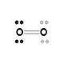](http://www.google.com/imgres?q=%22lewis+dot+diagram+for+O2%22&hl=en&safe=active&gbv=2&biw=1280&bih=882&tbm=isch&tbnid=00WcrTcEmBnh9M:&imgrefurl=http://www.ausetute.com.au/lewisstr.html&docid=gifWGyhso17eDM&imgurl=http://www.ausetute.com.au/images/edoto2vs.gif&w=100&h=100&ei=ywwLT66pMqLW0QHx_uT0DQ&zoom=1) [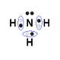](http://www.google.com/imgres?q=%22lewis+dot+diagram+for+O2%22&hl=en&safe=active&gbv=2&biw=1280&bih=882&tbm=isch&tbnid=x1tSyh4uqJgiJM:&imgrefurl=http://www.ausetute.com.au/lewisstr.html&docid=gifWGyhso17eDM&imgurl=http://www.ausetute.com.au/images/edotnh3l.gif&w=96&h=96&ei=ywwLT66pMqLW0QHx_uT0DQ&zoom=1)**

**[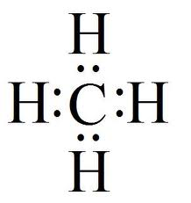](http://www.google.com/imgres?q=%22lewis+dot+diagram+for+atom+of+h2&start=504&hl=en&safe=active&gbv=2&biw=1280&bih=882&tbm=isch&tbnid=Py3cDF_1kzwu6M:&imgrefurl=http://thelablads.blogspot.com/2011/10/electronic-structure-electron-dot.html&docid=GrWA65wOX2pYOM&imgurl=http://apchemrev.wikispaces.com/file/view/CH4.jpg/63176812/CH4.jpg&w=303&h=321&ei=HRELT9zIN4rt0gH0o6m9CQ&zoom=1&chk=sbg&iact=hc&vpx=184&vpy=517&dur=265&hovh=231&hovw=218&tx=74&ty=128&sig=107806882213169298742&page=24&tbnh=146&tbnw=149&ndsp=23&ved=1t:429,r:0,s:504) [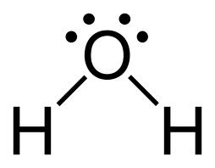](http://www.google.com/imgres?q=%22lewis+dot+diagram+for+atoms&hl=en&safe=active&gbv=2&biw=1280&bih=882&tbm=isch&tbnid=I36W90NwCLT_TM:&imgrefurl=http://www.ask.com/wiki/Structural_formula&docid=T8SnGdFbWoJiBM&imgurl=http://rpmedia.ask.com/ts?u=/wikipedia/commons/thumb/f/fa/Water-2D-flat.png/120px-Water-2D-flat.png&w=770&h=600&ei=bw8LT-moO6Pw0gH6qdXUDw&zoom=1)**

**http://cost.georgiasouthern.edu/chemistry/general/molecule/gifs/co2lew6.gif** 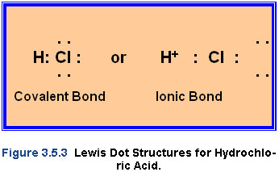

**Non-polar Bonds: Only occur with diatomics. Polar bonds are much more common Non-polar Molecules: symmetrical in shape, equal distribution of charge**

**Polar Bonds: All bonds except diatomics. Polar Molecules: asymmetrical in shape, unequal distribution of charge**

**Electronegativity difference (ionic character) determines if a bond is polar or non-polar (0=non-polar, anything else = polar)**

***Diatomic Bonds:***

**# of bonds diatomics form with themselves**

**O2 Double Bond N2 Triple Bond H2 Single Bond F2 Single Bond I2 Single Bond Cl2 Single Bond Br2 Single Bond**

***Determining the # of Bonds an Element Will Form***

**Maximum # of valence electrons – actual # of valence electrons = # of bonds the element will form**

**Max. # of valence electrons (for most elements)= 8 Max. # of valence electrons for Hydrogen (H) = 2**

***Symmetry:***

**Determines if a molecule is Polar or Non-polar**

**Use SNAP!**

**Symmetrical Non-polar Asymmetrical Polar**

**Non-polar, symmetrical = equal distribution of charge Polar, asymmetrical = unequal distribution of charge**

***Covalent Bonding Lewis Dot Diagrams:***

***Dot Diagrams for Molecules vs.Dot Diagrams for Atoms***

**\*1 bond = 2 electrons**



**Oxygen Molecule**



**Chlorine Molecule**

**[http://t3.gstatic.com/images?q=tbn:ANd9GcSEXOXqEE-ejkDukxgsmMU0MQAGhxyQoUc7J_DUW5Lv6jZmeTfrqQ](http://www.google.com/imgres?q=%22lewis+dot+diagram+for+Cl2%22&hl=en&safe=active&gbv=2&biw=1280&bih=882&tbm=isch&tbnid=vcBfS5mS0QWrHM:&imgrefurl=http://library.thinkquest.org/C006669/data/Chem/bonding/lewis.html&docid=Mq_bTsDYKOYA3M&imgurl=http://library.thinkquest.org/C006669/media/Chem/img/npcl.gif&w=84&h=53&ei=KA8LT8WYJurn0QGP5cWtAg&zoom=1)**

**Nitrogen Molecule**

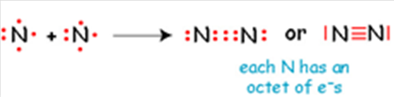

**Diatomics: Non-polar molecules with non-polar bonds shape: linear**

**[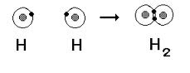](http://www.google.com/imgres?q=diatomic+molecule&hl=en&safe=active&gbv=2&biw=1280&bih=882&tbm=isch&tbnid=FAZ1-8UhEFe1iM:&imgrefurl=http://www.mrmungin.com/dot%20structures.htm&docid=HFmCLECMlaZKXM&imgurl=http://www.mrmungin.com/chembonds1.gif&w=287&h=111&ei=DRQLT4yVLqXY0QHMteDwCQ&zoom=1)**

**Molecule of water (H2O): Polar molecule with polar bonds shape: bent**

**[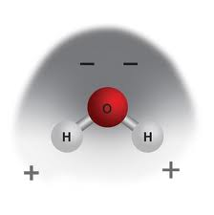](http://www.google.com/imgres?q=water+molecule&hl=en&safe=active&biw=1280&bih=882&gbv=2&tbm=isch&tbnid=iI3y69f3z21j_M:&imgrefurl=http://www.inquiryinaction.org/chemistryreview/solids/&docid=anuXjBxtSOyodM&imgurl=http://www.inquiryinaction.org/img/content/chapter2/water_new.jpg&w=350&h=353&ei=aBMLT6mkFsrr0gGO5P2sAg&zoom=1)**

**Molecule of Carbon Dioxide (CO2): Non-polar molecule with polar bonds shape: linear**

**[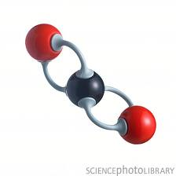](http://www.google.com/imgres?q=carbon+dioxide+molecule&hl=en&safe=active&biw=1280&bih=882&gbv=2&tbm=isch&tbnid=pIa7g7yt011x9M:&imgrefurl=http://www.sciencephoto.com/media/426104/enlarge&docid=q5dordGBrNm_YM&imgurl=http://www.sciencephoto.com/image/426104/large/F0039081-Carbon_dioxide_molecule-SPL.jpg&w=530&h=530&ei=vBQLT92KA-Xr0gHY2aTHAg&zoom=1&iact=rc&dur=411&sig=107806882213169298742&page=2&tbnh=151&tbnw=161&start=20&ndsp=20&ved=1t:429,r:8,s:20&tx=97&ty=74)**

**Molecule of Ammonia (NH3): Polar molecule with polar bonds shape: pyramidal**

**[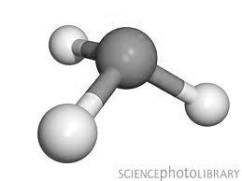](http://www.google.com/imgres?q=ammonia+molecule&hl=en&safe=active&gbv=2&biw=1280&bih=882&tbm=isch&tbnid=5tUygA-KMF7qgM:&imgrefurl=http://www.sciencephoto.com/media/6040/enlarge&docid=55Rj4-w5t0TeCM&imgurl=http://www.sciencephoto.com/image/6040/large/A6020038-Ammonia_molecule-SPL.jpg&w=530&h=397&ei=9xQLT4WcLeH40gG72fTjCA&zoom=1)**

**Molecule of CX4 (ex. = CCl4): Non-polar molecule with polar bonds shape: tetrahedral**

**[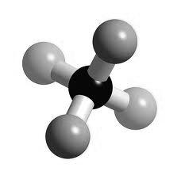](http://www.google.com/imgres?q=MOLECULE+OF+cF4&hl=en&safe=active&gbv=2&biw=1280&bih=882&tbm=isch&tbnid=6eZIS-tp6kuhjM:&imgrefurl=http://www.3dchem.com/inorganicmolecule.asp?id=138&docid=wlf0SHCAsxD0jM&imgurl=http://www.3dchem.com/inorganics/CF4.jpg&w=549&h=533&ei=ajcMT4_iJubb0QGFyrCSCg&zoom=1)**

***Compounds with both Ionic and Covalent Bonds:***

**Contain a metal (positive) being attracted to a negative polyatomic ion (found on Table E)**

**Ex.) CaSO4 Ca + SO4 ionic bonding metal covalent bond**

**HINT: look for a metal and a polyatomic ion**

***Dipoles:***

**Dipoles occur in molecules (covalent bonding) in which one end is slightly positive and another is slightly negative due to differences in electronegativity**

**[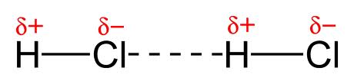](http://www.google.com/imgres?q=HCl+dipole&hl=en&safe=active&gbv=2&biw=1280&bih=882&tbm=isch&tbnid=HthdQnn81mztCM:&imgrefurl=http://en.wikipedia.org/wiki/File:Dipole-dipole-interaction-in-HCl-2D.png&docid=GxgzTnsNs2nhMM&imgurl=http://upload.wikimedia.org/wikipedia/commons/5/59/Dipole-dipole-interaction-in-HCl-2D.png&w=1100&h=263&ei=DDgMT_nxOuHr0gGuu-HXBQ&zoom=1)**

***Molecule Ion Attractions:***

**Occur when a positive and/or negative ion is attracted to the negative and/or positive pole of a molecule**

**Ex. 1) NaCl (aq) aq = dissolved in water (H2O) Sodium Chloride is an ionic compound that will disassociate when dissolved in water Na + Cl -**

**[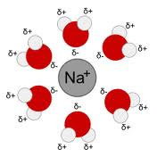](http://www.google.com/imgres?q=molecule+ion+attraction&hl=en&safe=active&gbv=2&biw=1280&bih=882&tbm=isch&tbnid=owRadInqYiITuM:&imgrefurl=http://en.wikipedia.org/wiki/Solvation&docid=VdezqaMb0auVzM&imgurl=http://upload.wikimedia.org/wikipedia/commons/thumb/6/67/Na%252BH2O.svg/220px-Na%252BH2O.svg.png&w=220&h=220&ei=UzgMT-OWNcbz0gGf_vSKBg&zoom=1)**

**Ex. 2) KBr mixed with ammonia (NH3)**

***Hydrogen Bonding – an Intermolecular Force:***

**-When a sample of H2O, NH3, or HF is in a container, the poles of each substance will line up positive to negative.**

**-O, N, and F are the most electronegative elements on the Periodic Table. When they bond with Hydrogen, this force is present.**

**Intermolecular Force: a force present between molecules**

**[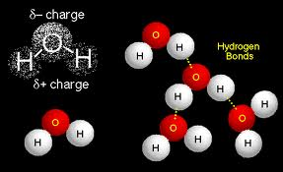](http://www.google.com/imgres?q=hydrogen+bonding&hl=en&safe=active&gbv=2&biw=1280&bih=882&tbm=isch&tbnid=PAYKSSDg8rXlGM:&imgrefurl=http://www.sp.uconn.edu/~terry/images/mols/atomfig5.html&docid=nLcRu9elT7QUHM&imgurl=http://www.sp.uconn.edu/~terry/images/mols/waterHbonds.GIF&w=521&h=318&ei=9zgMT6fkC6nZ0QHyrPmMBg&zoom=1)**

**This intermolecular force accounts for the unusually high boiling point of water**

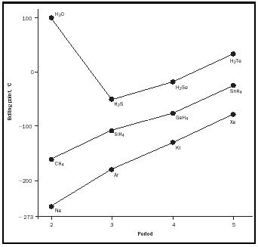

***Metallic Bonding:***

**NOT A BOND BETWEEN METALS!!!!!!!!!!!!!!!!!!!**

**Metallic bonding is a term used to describe the movement of electrons on the surface of a metal**

**“Sea of mobile electrons” is a phrase often tied to metallic bonding**

**The movement of electrons on metals explains why they are such good conductors of electricity and heat**

**-What displays metallic bonding? The answer to this question is always a metallic element**

**Electrolyte = something that conducts electricity**

***London Dispersion:***

**A temporary force of attraction that occurs between positive and negative poles of a non-polar molecule**

**Ex.) H2**

**[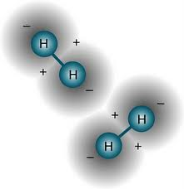](http://www.google.com/imgres?q=london+dispersion+attractions&hl=en&safe=active&gbv=2&biw=1280&bih=882&tbm=isch&tbnid=tIJ9b7sHINtTMM:&imgrefurl=http://thestephenation.blogspot.com/2009/09/london-dispersion-forces.html&docid=JqMbnnxFHfddjM&imgurl=http://2.bp.blogspot.com/_NvQHHJRdJ9o/SqV9I2h3mdI/AAAAAAAAAmM/DzF79KCE7Fw/s320/hydrogen.jpg&w=310&h=320&ei=QDoMT8GrK-Xw0gG4--XVDQ&zoom=1)**

***Coordinate Covalent Bond:***

**Ex.) NH4+ and H3O+**

**In these molecules, a proton is attracted to the lone pair of electrons, forming a coordinate covalent bond. This results in a positive charge.**

**Proton: a Hydrogen (H) atom that has lost its electron**

**Lone Pair of Electrons: pair of electrons that is not found in a bond**

**[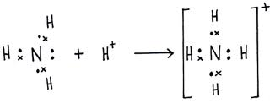](http://www.google.com/imgres?q=coordinate+covalent+bond+examples&hl=en&safe=active&gbv=2&biw=1280&bih=882&tbm=isch&tbnid=sbkEbxohn3gxjM:&imgrefurl=http://hsc.csu.edu.au/chemistry/core/monitoring/chem944/944net.html&docid=99lZfTtozUFZjM&imgurl=http://hsc.csu.edu.au/chemistry/core/monitoring/chem944/ammonium.gif&w=400&h=162&ei=cToMT8OEGobh0QGPk_mbBg&zoom=1)**

**H20 (water) becomes H30+ (Hydronium), and NH3 (ammonia) becomes NH4+ (ammonium)**

**OH- H2O H3O+ base neutral acid**