Kinetics- the measure of reaction rates

* “Collision Theory”- in order for a reaction to occur the reacting particles must “collide” with proper speed/energy and orientation/direction. If both the effectiveness and frequency increase the rate of the reaction also increases.

Factors that increase or decrease the rates of a reaction:
1. Nature of Reactants
- ionic compounds react faster
- covalent compounds react slower
2. Temperature (temp = average kinetic energy)
- increase temp = increased rate
- decrease temp = decreased rate
3. Concentration
- increase concentration = increased rate
- decrease concentration = decreased rate
4. Pressure (only effects gas)
* if a solid or liquid has a change in pressure = NO EFFECT!
- increase pressure = decreased volume = increased rate
- decrease pressure = increase volume = decreased rate
5. Surface area
* powder has the greatest surface area
- increase surface area = increased rate
- decrease surface area = decreased rate
6. Catalyst
- increase rate of reaction by offering an alternate pathway with a lower activation energy

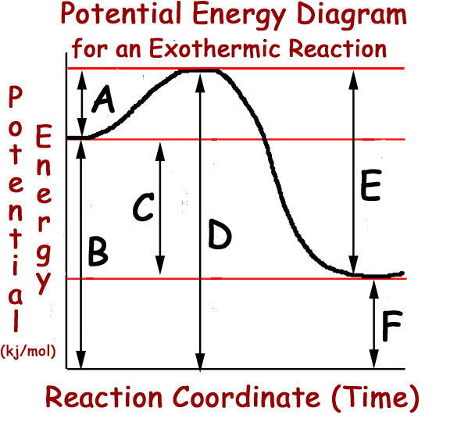

* Releases energy
A. Activation energy forward
B. Potential energy reactants
C. ΔH
D. Activated complex
E. Activation energy reverse
F. Potential energy of products

Hints for exothermic
1. The potential energy of reactants is greater then the potential energy of products
2. ΔH= heat of reaction is negative (-)
3. Activation energy forward is less then the activation energy reverse
4. Heat as a product
reactantsproducts + heat/energy (KJ)

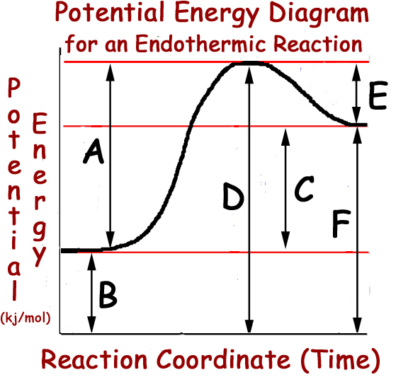

*Energy absorbed
A. Activation energy forward
B. Potential energy of reactants
C. ΔH
D. Activated complex
E. Activation energy reverse
F. Potential energy of products

Hints for endothermic reactions
1. Potential energy of reactants is less the potential energy of products
2. ΔH= positive(+)
3. Activation energy forward is greater then activation energy reverse
4. Uses energy
reactant + heat/energy(KJ)products
ΔH = Heat of Reaction (table I)
ΔH= heat of products- heat of reactants
If ΔH is:
negative= exothermic
positive= endothermic

Equilibrium
1. Rate of forward reaction is equal to the rate of the reverse reaction
example: A + B ← AB + heat
forward reaction= synthesis and exothermic
reverse reaction= decomposition and endothermic
2. Concentrations are constant= remain the same
3. Chemical equilibrium
reactants← products

Types of equilibrium
1. Phase equilibriums- occurs during a phase change at constant temperature
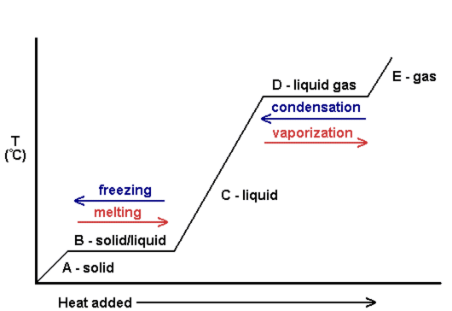
a) s ← l
b) l ← g
c) s ←g

2. Solution equilibrium- rate of dissolving is equal to the rate of precipitate being formed NaCl(s) ← NaCl(aq)
H20
*Saturated solutions are considered to be in equilibrium( solid on bottom)
crystal that doesn’t dissolve

Le Challer’s Principle
- explains what occurs when a “stress” is added to a reaction at equilibrium
examples of a stress
1. Increase/decrease the concentration [ ]
[H₂0]= concentration of water
2. Increase/decrease the temperature
3. Increase/decrease the pressure (if a gas is present (g) and the moles of reactants and procedures after)
4. A catalyst is added- which has no effect on equilibrium because a catalyst increases the rate of both the forward and reverse reactions
When a reaction at equilibrium is stressed it “shifts” to reduce that stress and re-establishes a new equilibrium
shift right= favor the forward reaction Terms of
shift left= favor the reverse reaction LeChatliers
Hints
increase= away
decrease= forward
shift right=reactants decrease and products increase
shift left= reactants increase and products decrease

For pressure= count the total number of moles on the reactant side and the products
- if they are the same= no effect
- if they are different:
increase in pressure= shift to smaller #of moles
decrease in pressure= shift to larger #of moles

Entropy

Entropy is a measure of randomness or disorder.

solid liquid->gas = an increase in entropy

gas->liquid-> solid = a decrease in entropy

Systems in nature tend to go to or favor LOWER ENGERY (EXOTHERMIC) and HIGHER ENTROPY (RANDOMNESS)

