**Organic Chemistr**

**the study of carbon**  
  
**Properties of Carbon**

1. **non-metal**
2. **covalent bonding**
3. **relatively low melting/boiling points**
4. **most are insoluble in water because their non-polar**
5. **carbon atoms bond with each other in chains, rings, and networks**
6. **carbon forms 4 bonds, 1 hydrogen bond, oxygen forms 2 bonds, nitrogen forms 3 bonds, and halogens(group 1) form 1 bond**

**Homologous Hydrocarbons**  
  
**Homologous= differs by 1 carbon + 2 hydrogen atoms in the series**  
  
**Hydrocarbon= compounds that contain hydrogen + carbon ONLY!**  
**Alkanes- hydrocarbon that contains a carbon-carbon single bond-> Saturated hydrocarbon= Single bonds only**  
  
**End in the “ane” suffix.**  
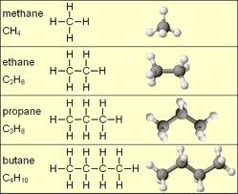  
  
  
  
**Alkene- unsaturated( multiple bonds) hydrocarbon that contains double carbon-carbon bonds.**  
  
**-There must be at least 2 carbon atoms present to form an alkene.**  
**-Each alkene will contain only one double bond.**  
  
**ends in “ene”**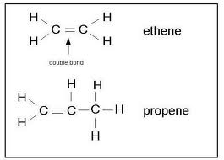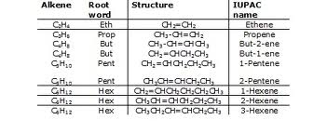

**Alkyne- unsaturated(multiple bonds) hydrocarbon that contains triple carbon bonds.**  
  
**- There must be at least 2 carbon atom present to form an alkyne.**  
  
**- Each alkyne will contain only one triple bond.**  
  
**Ends in “yne”**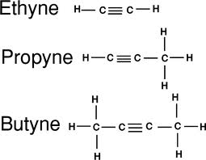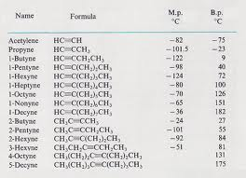

**Isomers- same molecular formula different structural formulas**  
  
**Same # of carbon + hydrogen atoms but they are arranged differently.**  
  
**-In order to have isomers with the hydrocarbon, you must have a minimum of 4 carbon atoms in the compound.**  
  
**Naming Isomers**

1. **find the longest carbon chain & circle it.**
2. **# of carbon from left to right and right to left, choosing the lowest # for each carbon atom.**
3. **name(location of carbon # + # of carbons) Whatever is not included in your circle chain.**

**\* 1 carbon atom= methyl**  
**2 carbon atoms= ethyl**  
**3 carbon atoms= propyl**  
**4. names your longest carbon chain( which your circled in step one)**

**Hexane**  
  
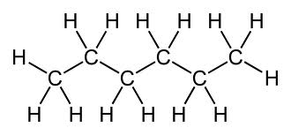C**7 H 14**  
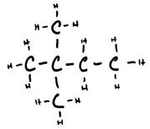**2, 2 dimethyl butane**  
  
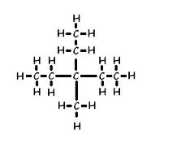**3,3 ethyl, methyl octane**  
  
  
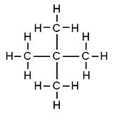**2,2 dimethyl propane**

**Isomers of Alkenes + Alkynes**  
  
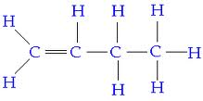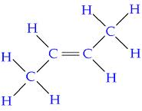  
  
https://lh5.googleusercontent.com/V-_vEA_mdReQwm9EA8LZIgcUJZQpG44cLFmEzARaLc_A317jc17nFgUyt4qrgISFiqTwTczmoybW_qGIXuGa5dMoHbwsTVA3U8f_IAeCAabGdoZ-l3c  
https://lh6.googleusercontent.com/NBpK9Kef4IjhMSX550qIRk10p92QSei3XXTTby71Vvl02qM5hMFZXn099nOwNXkZ4eSsrqVldTef4-RZPtzRwcEho-EtzHbsTY0TtMGXzZDYOp7Gw88  
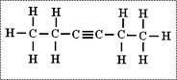

**Halide (halocarbon)- organic compound that contains one or more halogen.(group 17)**  
  
**F-(fluoro) Br-(bromo)**  
**Cl-(chloro) I- (iodo)**  
  
**CH3CHClCH3**  
  
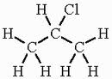**Chloro propane**  
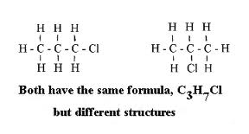

**Alcohol- organic compounds that contain OH end in “ol”**  
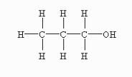  
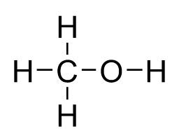  
  
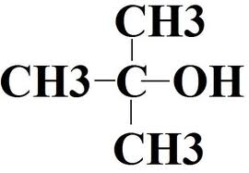  
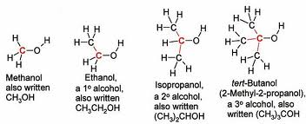  
**Primary(1 degree) Secondary(2 degree) Tenitary(3 degree) alcohols**

1. **circle the OH**
2. **box the carbon bond to the OH**
3. **count the # of carbons bonded to the box**

**1-primary**  
**2-secondary**  
**3-teritary**  
  
  
**Ethers**  
  
**ends in ether**  
  
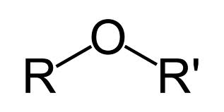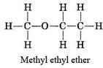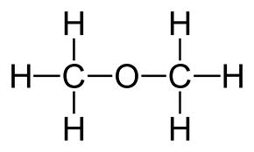  
  
**Aldenydes**  
  
**ends in “al”**  
  
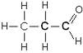  
**CH3CH2CHO -> CHO me your aldehyde**  
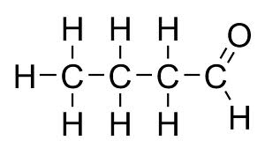  
**butanal**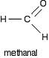https://lh6.googleusercontent.com/wNuFv2omBaDPcKhkP6n4vtYc6SllvMILDDGBJJoXfDLg7r2VSKAjPbVGhmx1ZdYPX6onltCFLgiPkn0m2cHLxOgiETq0jbac84Bg1WOCwt4LbV44Eqg

**Ketones**  
**ends in “one”**  
  
**CH3COCH2CH2CH3**  
**2 Pentanone**   
https://lh4.googleusercontent.com/Dokftjwz5Y-W-yr2ZaYalqVjw33o4E37N7FpfriYYYLzVKo3kuzEeVdS7IrYNML2v-6UwvG8OFVIoChro6TpP_B4K_TvL9PWNlLs4jLt8_YDfbCMhY0  
  
**3 pentanone**  
https://lh6.googleusercontent.com/juzFJ-AAjl_XBInjbipg8XQS1i4Kdir8XORV0CdoeeLCVtbIUDcY8S1Tg7l8Nnwn7tfNISBxFtaojyxNx_k9Gi3AM2EZ79wDr-Dj0qss_slyn6j6csA  
  
**2 hexanone**https://lh6.googleusercontent.com/6b15gFIDNr8OJ2uytjlD6gWlGnzydfSEJWhWafSPmgDesjp7HSZJuQOFLzQimSPcUW2wDk910bu0k_ddZQloQaKy-E4AcUTYYM3_EFK999Qodbo13DM  
  
**2 propanone**https://lh4.googleusercontent.com/xv4305VS7oRvhFLyvSICjsa8ZRwMPYNi3ANF4MH87H0Ws_uPTjC0Y-1-5DuzsX2Yl4cd9OOPohySByhwQFn-eopUonIpwM81JSauh7XEQiOeHFnVsfU

**Organic acid = COOH**  
  
**ends in “oic acid”**  
  
**propanoic acid**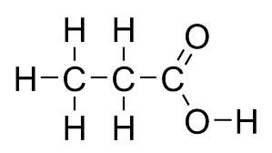  
**methanoic acid**  
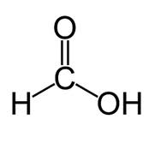  
**Pentanoic acid**https://lh5.googleusercontent.com/JiOAoH7NerSksKS4n4cjw0YbTWJuXoUUnoI51QocGvRuMmdEBhHHRVxXLax6mgtsjwmTh20WpAnQp5XZYR9HIp9ZNOE44OaNMqJIQNXY9g52uFHO1D4

**Ester** 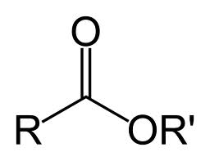  
  
**ends in “oate”**  
  
**- an ester is produced by reacting an alcohol and an organic acid.**  
**\*\*\*\* esters smell fantastic!**  
  
**Methyl propanoate**https://lh5.googleusercontent.com/2CCwm7G3MR2-ZsQFmQLWFglIAoo1WeEZClVaqjAmzi9TdOPThLrRQKUAnE-Ye1gk0LnurEtiQ_JY1lOSEgBl8qruZBKeyF9obFY1S8Yqr65mOsmncqk  
  
**Propyl etheranoate**https://lh6.googleusercontent.com/WkMyUOqG-OQujT7OT3HcyaiQ6-mAxhFkwb9f1-Og_KPvdqW2XVzpZ5N_F4O-iso203JpiVsuykdm4DdXTyPMBZlcjb0B-Txb9rcHF8bUTqj_jwTvFFI  
  
  
  
  
**Ethyl ethanoate**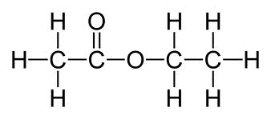

**Amine** 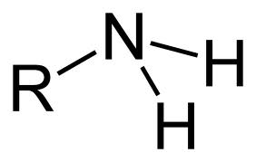  
  
**ends in “amine”**  
  
**2 propanamine isomer propanamine**  
https://lh3.googleusercontent.com/X23Anu84HoZu6iJUktXyPQ0pVmDYGg6hjenrx-U5v95sW7Qg_gOCpPy1DxG4fYLhmDW-N-gMPSZJyi__lrjuxw4Ny8EzmiuFuSovQ-dLZaiIgoabCoM  
  
**There are organic compounds called amino acids. They contain an amine group + an organic acid group on the same carbon chain.**

  
**. .**   
**amine acid = amino acid**  
  
**Amide** 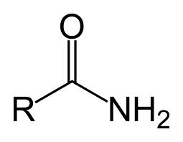  
  
**ends in “amie”**  
  
**propanamide**https://lh6.googleusercontent.com/pnBE937z2ThTnKcgMc7M2voo4YS2IdvSfoZ8FDmdyfOdYblRY3XDep0yHkbHv5gwkxz97CpNok_ZuBe9Wi3WtdQwkyN8nJDJREdjUExHVViy5P41F6I

**Organic Reactions**

1. **combustion- the burning of an organic compound in the presence of oxygen(O2) to produce CO2 and H2O.**

**organic compound + O2 -> CO2 + H2O**  
  
**Table I the first 6 reactions are examples of combustion.**  
  
**2. Substition- ( halogenation)**  
  
**C2H6 + Cl2 -> C2H5Cl + HCl**  
**chlorination**

  
  
**3. Addition- (halogenation/group 17) or (hydrogenation/ hydrogen)**  
  
**unsaturated hydrocarbon. -> 1 bond break**  
**(double or triple carbon bonds)**

**4. Esterification- the production of an ester. Esters smell fantastic!**

**Acid + Alcohol -> Ester + Water(H2O)**

[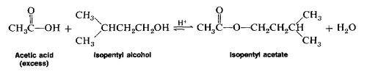](http://www.google.com/imgres?q=organic+esterification+reaction&hl=en&safe=active&gbv=2&biw=1024&bih=652&tbm=isch&tbnid=dIW5QCw5zV8toM:&imgrefurl=http://www.dbooth.net/mhs/ap/isoamylacetate.html&docid=PCJdvdPrfpDN5M&imgurl=http://www.dbooth.net/mhs/ap/ester01.gif&w=1764&h=336&ei=RMPYT9GCDc-3hAe5hIi4Cg&zoom=1&iact=hc&vpx=459&vpy=440&dur=3474&hovh=98&hovw=515&tx=275&ty=82&sig=115648754287022221260&page=4&tbnh=33&tbnw=175&start=55&ndsp=20&ved=1t:429,r:18,s:55,i:309)

1. **saponficiation- the production of soap(smells horrible)**  
   [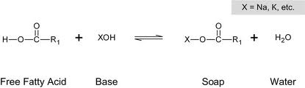](http://www.google.com/imgres?q=organic+saponification+reaction&hl=en&safe=active&gbv=2&biw=1024&bih=652&tbm=isch&tbnid=KKEfgtXpbUqOgM:&imgrefurl=http://ww2.mackblackwell.org/web/research/all_research_projects/2000s/2092/mbtc-2092.htm&docid=UTgN3V8cDA4O9M&imgurl=http://ww2.mackblackwell.org/web/research/all_research_projects/2000s/2092/images/MBCTcompletionreport2092final_img_5.jpg&w=774&h=227&ei=w8PYT-rUBIm3hQf01fXdAw&zoom=1&iact=hc&vpx=566&vpy=334&dur=967&hovh=121&hovw=415&tx=347&ty=74&sig=115648754287022221260&page=1&tbnh=51&tbnw=175&start=0&ndsp=15&ved=1t:429,r:9,s:0,i:100)  
   **6. fermentation- the production of alcohol (ethanol)**  
   **Glucose -> CO2 + ethanol**

[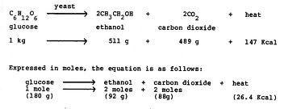](http://www.google.com/imgres?q=organic+fermentation+reaction&hl=en&safe=active&gbv=2&biw=1024&bih=652&tbm=isch&tbnid=nAN1E00SEUu0SM:&imgrefurl=http://www.cd3wd.com/cd3wd_40/vita/ethanol/en/ethanol.htm&docid=cmBu8QPmOw8leM&imgurl=http://www.cd3wd.com/cd3wd_40/vita/ethanol/GIF/UEFXA2.GIF&w=1468&h=534&ei=FsTYT5qCNMbNhAemkJHaAw&zoom=1&iact=hc&vpx=608&vpy=387&dur=2880&hovh=135&hovw=373&tx=265&ty=132&sig=115648754287022221260&page=3&tbnh=62&tbnw=171&start=35&ndsp=21&ved=1t:429,r:15,s:35,i:234)

**7. polymerization- production of a polymer from many small monomers.**  
  
**example: nylon, plastic, rayon, polyethylene**   
  
**\*n(C2H2) 🡪 (C2H2)n**  
**\* n= very large # \***  
  
**- if the monomer is unsaturated it is called addition polymerization.**  
  
**\* if water is produced as a result of a polymerization = condensation polymerization**