Redox – Reduction/Oxidation
Reduction – gain electrons (GER = gain electrons reduction)
Oxidation – loss of electrons (LEO = lose electrons oxidation )
Reduction and oxidation occur simultaneously (at the same time). It’s an exchange of electrons.

Rules for Assigning Oxidation Numbers
1. The first element is always positive, the last element is always negative (except NH3).
2. All free elements have an oxidation number = 0
Naº Cl2º S8º
3. Group 1 = +1 Group 2 = +2
4. Fluorine = -1
5. Hydrogen - = +1 (1st element except NH3)
- = -1 (2nd and last element except NH3)
6. Oxygen - = -2 (95% of the time 0
- = +2 (in OF2)
- = -1 (X2O2)
7. The sum of the oxidation numbers in a compound = 0.
8. The sum of the oxidation numbers in a polyatomic ion (Table E) = charge on the ion.
Identifying a redox reaction – look for the reaction with an element on
the reactant or product side.
LEO
-»-»-»-»-»-»-»-»-»-»-»-»
-3 -2 -1 0 1 2 3
«-«-«-«-«-«-«-«-«-«-«-«
GER
• Answer from redox reactions always come from the reactants side. (left).

Half Reactions (must include electrons)
LEO – electrons must be written on the right side of the
equation (products).
GER – electrons must be written on the left side of the
equation (reactants).
*at the end, the electrons lost must be equal tot eh electrons gained.*
Mgº + Cu+2 - » Mg+2 + Cuº
Oxidation - Mgº -» Mg+2 + 2e-
Reduction – Cu+2 + 2e- -» Cuº
- The species being oxidized is also called the reducing agent.
- The species being reduces is also called the oxidizing agent.

Electrochemical Cell / Voltaic Cell / Battery
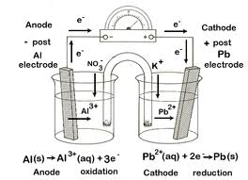
1. Anode = site of oxidation.
Cathode = site of reduction.
2. Anode = negative, decrease in size.
Cathode = positive, increase in size.
3. Electrons always flow from the anode to the cathode through the metal wire. (on Table J the anode is above the cathode).
4. Ions migrate through the salt bridge.
5. Electrochemical cell / voltaic cell / battery is a spontaneous redox reaction.
6. Chemical energy -» electrical energy.

Electrolytic Cell – used for electroplating
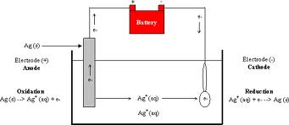
Electrolytic
Anode – oxidation, positive.
Cathode – reduction, negative.
- Electrons flow from the anode to cathode through the
metal wire.
- Non – spontaneous – redox reaction = it requires an outside power source (BATTERY).
- Electrical energy -»chemical energy.
Similarities
1. Anode = oxidation.
Cathode = reduction.
2. Electrons flow from the anode to the cathode through
the metal wire.
3. Anode = decrease in size.
Cathode = increase in size.

Differences
1. Charges of anode/cathode.
2. Voltaic – spontaneous.
Electrolytic = non spontaneous.
3. Voltaic = salt bridge.
Electrolytic = no salt bridge.
4. Voltaic = volt meter.
Electrolytic = battery.
5. Voltaic = chemical -» electrical.
Electrolytic = electrical -» chemical.

